TS C102 V3.0.0 (1999-10)
Technical Specification
China Wireless Telecommunication Standard (CWTS); Working Group 1 (WG1);
Physical Channels and Mapping of Transport
Channels onto Physical Channels

Content
Content 2
1 Scope 3
2 References 3
3 Definitions and abbreviations 3
4 Transport channels 5
4.1 Transport channels 5
4.1.1 Dedicated transport channels 5
4.1.2 Common transport channels 5
5 Physical channels 7
5.1 Frame structure 7
5.1.1 General description 7
5.1.2 Special time slot for synchronization 8
5.1.2.1 Downlink Pilot Time Slot (DwPTS) 8
5.1.2.2 Uplink Pilot Time Slot (UpPTS) 9
5.1.2.3 Guard Period (G) 9
5.2 Dedicated physical channel (DPCH) 9
5.2.1 Spreading codes 9
5.2.1.1 Multicode transmission with fixed spreading 9
5.2.1.2 Single code transmission with variable spreading 9
5.2.2 Burst Types 9
5.2.2.1 Transmission of L1 Control Signals 10
5.2.3 Training sequences for spread bursts 11
5.2.3.1 Midamble Transmit Power 12
5.3 Common control physical channels (CCPCH) 12
5.3.1 Downlink common control physical channel 12
5.3.1.1 Spreading codes 12
5.3.1.2 Burst Types 12
5.3.1.3 Training sequences for spread bursts 12
5.3.2 The physical random access channel (PRACH) 12
5.3.2.1 Spreading codes 12
5.3.2.2 Burst Types 13
5.3.2.3 Training sequences for access bursts 13
5.4 The physical synchronization channel (PSCH) 13
6 Mapping of transport channels to physical channels 13
6.1 Dedicated Transport Channels 13
6.2 Common Transport Channels 14
6.2.1 The Broadcast Channel (BCH) 15
6.2.2 The Paging Channel (PCH) 15
6.2.3 The Forward Access Channel (FACH) 15
6.2.4 The Random Access Channel (RACH) 15
6.2.5 The Synchronization Channel (SCH) 16
6.3 Multiframe structure 16
History 17

- Scope
This document describes the burst structure in physical channels and mapping of transport channels onto physical channels in TD-SCDMA.
- References

[1] B. Steiner, P. Jung: Uplink channel estimation in synchronous CDMA mobile radio systems with joint detection. The fourth International Symposium on Personal, Indoor and Mobile Radio Communications (PIMRC’93), Yokohama, Japan, September 8-11, 1993.
[2] CWTS TS C105 (V3.0.0) : “Physical layer procedure description”
[3] CWTS WG1 1999/xxx, “Method and Principle of Uplink Synchronization Used in TD-SCDMA RTT”
[4] CWTS TS C103 (V3.0.0) : “Multiplexing and channel coding”
[5] CWTS TS C104 (V3.0.0) : “Spreading and modulation”

- Definitions and abbreviations

BCH | Broadcast Channel
CCPCH | Common Control Physical Channel
CDMA | Code Division Multiple Access
DL | Downlink
DPCH | Dedicated Physical Channel
DRX | Discontinued Receive
DTX | Discontinued Transmit
DwPTS | Downlink Pilot Time Slot
FACH | Forward Access Channel
FDD | Frequency Division Duplex
FEC | Forward Error Correction
G | Guard Period (Switching point)
GP | Guard Period
GSM | Global System for Mobile Communication
NRT | Non-Real Time
ODCH | ODMA Dedicated Transport Channel
ODMA | Opportunity Driven Multiple Access
ORACH | ODMA Random Access Channel
PCH | Paging Channel
PDU | Protocol Data Unit
PRACH | Physical Random Access Channel
PSCH | Physical Synchronisation Channel
RACH | Random Access Channel
RLC | Radio Link Control
RT | Real Time
RU | Resource Unit
SACCH | Slow Associated Control Channel
SCH | Synchronization Channel
SDCCH | Stand-alone Dedicated Control Channel
TA | Timing Advance
TCH | Traffic Channel
TDD | Time Division Duplex
TDMA | Time Division Multiple Access
TD-SCDMA | Time Division Synchronous CDMA
UL | Uplink
UpPTS | Uplink Pilot Time Slot
VBR | Variable Bit Rate

- Transport channels
  - Transport channels
The chapter describes transport channels that are required for data transfer. Transport channels are the services offered by layer 1 to the higher layers. A general classification of transport channels is two groups:
- common channels (where there is a need for in-band identification of the UEs when particular UEs are addressed)
- dedicated channels (where the UEs identified by the physical channel, i.e. code , time slot and frequency)
    - Dedicated transport channels
The Dedicated Channel (DCH) is an uplink or downlink transport channel that is used to carry user or control information between the network and a UE.
Two types of dedicated transport channels have been identified:
- Dedicated Channel (DCH) characterized by:
- existence in uplink or downlink,
- possibility to use beamforming,
- possibility to use uplink synchronization (uplink only),
- possibility to change rate fast,
- closed loop power control (uplink only),
- inherent addressing of UEs.
- ODMA Dedicated Transport Channel (ODCH) characterized by:
- possibility to change rate fast
- closed loop power control,
- closed loop timing advance control,
- temporary addressing of UEs.
[Editors Note: ODMA in TD-SCDMA is optional.]

    - Common transport channels
Common transport channels are:
- Broadcast Channel (BCH) characterized by:
- existence in downlink only,
- low fixed bit rate,
- requirement to be broadcast in the entire coverage area of the cell.
The Broadcast Channel (BCH) is a downlink transport channel that is used to broadcast system- and cell-specific information.
- Paging Channel (PCH) characterised by:
- existence in downlink only,
- possibility for sleep mode procedures,
- requirement to be broadcast in the entire coverage area of the cell.
The Paging Channel (PCH) is a downlink transport channel that is used to carry control information to a UE when the system does not know the location cell of the UE.
- Forward Access Channel(s) (FACH) characterized by:
- existence in downlink only,
- possibility to use beamforming,
- possibility to use power control,
- possibility to change rate fast (each 5ms),
- requirement for in-band identification of UEs.
The Forward Access Channel (FACH) is a downlink transport channel that is used to carry control information to a UE when the system knows the location cell of the UE. The FACH may also carry short user packets.
- Random Access Channel(s) (RACH) characterized by:
- existence in uplink only,
- possibility to use beamforming,
- limited data field.
- collision risk,
- possibility to use open loop and closed loop uplink synchronization,
- open loop and closed loop power control,
- requirement for in-band identification of the UEs.
The Random Access Channel (RACH) is a reverse link transport channel that is used to carry control information from UE. The RACH may also carry short user packets.
- ODMA Random Access Channel (ORACH) characterized by:
- existence in relay links,
- collision risk,
- open loop power control,
- no timing advance control,
- requirement for in-band identification of the UEs.
[Editors Note: ORACH in TD-SCDMA is optional.]
- Synchronization Channel (SCH) characterized by:
- existence in downlink and uplink,
- possibility to use beamforming,
- low fixed bit rate,
- requirement to be broadcast in the entire coverage area of the cell (downlink only).
- Uplink shared Channel (USCH)
Used in uplink only
Possibility to use beamforming
Possibility to use open-loop power control
Possibility to use open-loop uplink synchronization
requirement for in-band identification of the UEs
[editor:spec. for USCH is FFS ]
- Downlink shared Channel (DSCH)
Used in downlink only
requirement for in-band identification of the UEs.
[editor:spec. for DSCH is FFS]

- Physical channels

All physical channels take four-layer structure of superframes, radio frames, subframes and time slots/codes. Depending on the resource allocation, the configuration of subframes or time slots becomes different. All physical channels need guard symbols in every time slot. The time slots/codes are used in the sense of a TDMA component to separate different user signals in the time and the code domain. The physical channel signal format is presented in Figure 1.
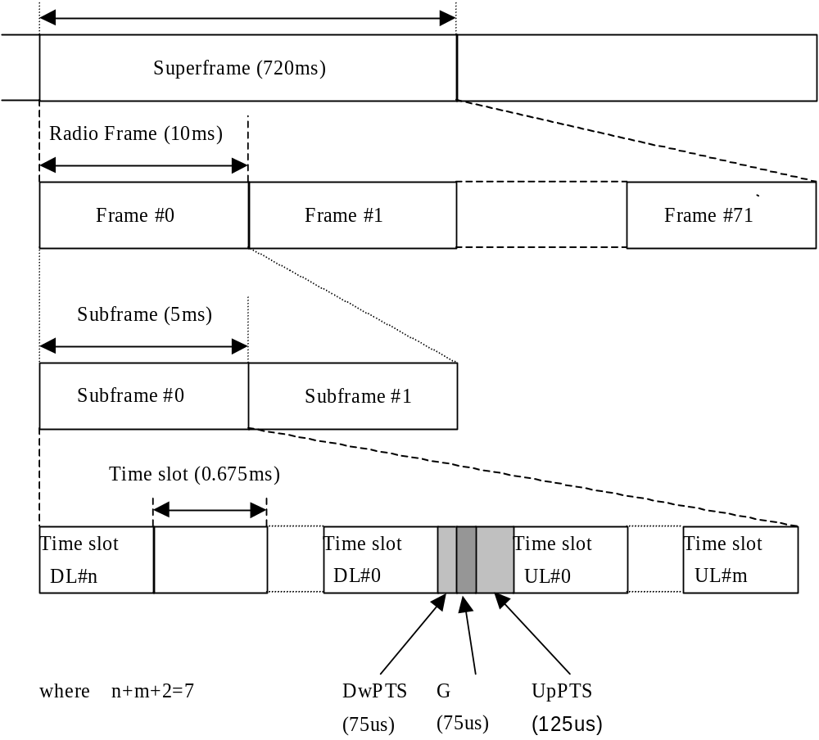The basic physical channel is defined as the association of one code, one time slot and one frequency.

Figure 1. Physical channel structure

  - Frame structure

    - General description
The radio frame has a duration of 10 ms and is subdivided into 2 subframes of 5ms each, and each subframe is then subdivided into 7 main time slots (TS) of 675 µs duration each and 3 special time slots: DwPTS (downlink pilot), G (guard period) and UpPTS (uplink pilot). The physical contents of the time slots are the bursts of corresponding length as described in section 5.2.2.

Among the 7 main time slots, for the uplink and the downlink are separated by single switching point, all the main time slots (at least one main time slot) before the single switching point are allocated as downlink, and all the main time slots (at least one main time slot) behind the single switching point are allocated as uplink (Figure 2). With such flexibility, the TD-SCDMA system can be adapted to different environments and deployment scenarios.
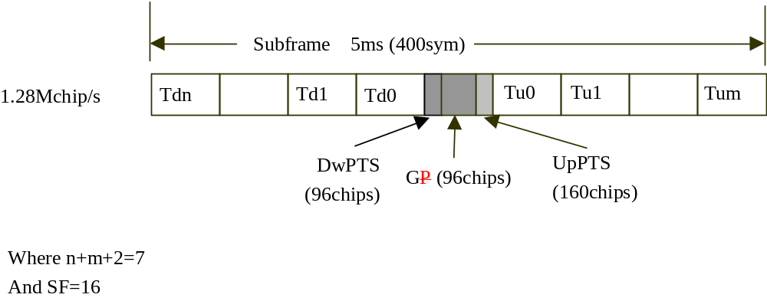
Figure 2. Sub-frame structure

Examples for symmetric and asymmetric UL/DL allocations are given in Figure 3.

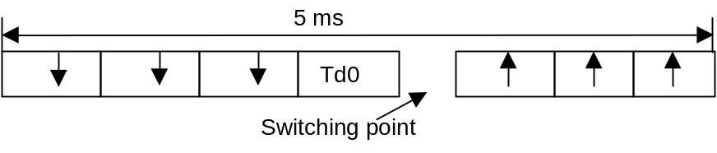
Symmetric DL/UL allocation

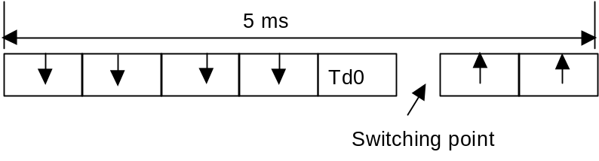
Asymmetric DL/UL allocation

Figure 3 subframe structure examples

    - Special time slot for synchronization

Downlink Pilot Time Slot (DwPTS)
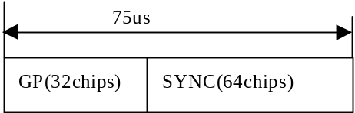The DwPTS(SYNC) in each subframe is designed for both downlink pilot and SCH. The Node B would transmit it omnidirectionally or sectorially at the full power level. This time slot is usually composed of 64 chips of SYNC and 32 chips of guard period as shown in Figure 4. The contents in the SYNC are a set of Gold code as defined in reference [5]. The Gold code set is designed to distinguish nearby cells for the purpose of easier cell measurement. The set of code could be repeated in the cellular network.

Figure 4. Burst structure of DwPTS

Uplink Pilot Time Slot (UpPTS)
The UpPTS in each subframe is designed for both uplink pilot and SCH. When a UE is in the status of air-registration and random access, it would transmit UpPTS followed by RACH. The time slot is usually composed of 128chips of SYNC1 and 32chips of GP as shown in Figure 5. The contents in the SYNC1 is a set of Gold code as defined in reference [5]. The Gold code set is designed to distinguish different UEs in access procedures.
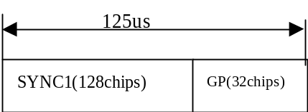

Figure 5. Burst structure of UpPTS

Guard Period (G)

The guard period in switching point of Tx to Rx for Node B has the duration of 75us (96 chips).

  - Dedicated physical channel (DPCH)

The DCH are mapped onto the dedicated physical channel.
    - Spreading codes
Two options are being considered for the bursts that can be sent as described below. Both options allow a high degree of bit rate granularity and flexibility, thus allowing the implementation of the whole service range from low to high bit rate.
Spreading factor of and the number of codes for multicode transmission are assigned independently for uplink and downlink. The number of time slots is also assigned independently for uplink and downlink.

Multicode transmission with fixed spreading
Within each time slot of length 675 μs, an additional separation of user signals by spreading codes is used. This means, that within one time slot of length 675 μs, more than one burst of corresponding length as described in section 5.2.2 can be transmitted. These multiple bursts within the same time slot can be allocated to different users as well as partly or all to a single user. For the multiple bursts within the same time slot, different spreading codes are used to allow the distinction of the multiple bursts.
The bursts as described in section 5.2.2 are designed in such a way, that up to 16 users’ bursts can be transmitted within one time slot, if the bursts are allocated to different users in the uplink.

Single code transmission with variable spreading
Within each time slot of length 675 us, a UE always uses single code transmission by adapting the spreading factor as a function of data rate. This limits the peak-to-average ratio of the modulated signal, and consequently the stress imposed to the power amplifier results in an improved terminal autonomy. Several UEs can be received by the base station in the same time slot, they are separated by their codes and the individual decoding can take profit of the joint detection.
    - Burst Types
As explained in the section 5.2.1, two options are being considered for the spreading. The bursts described in this section can be used for both options.
The burst type consist of two data symbol fields, a midamble of 144 chips and a guard period of 16 chips. The data fields of the burst type are 704chips long. The corresponding number of symbols depends on the spreading factor as indicated in Table 1 below. The guard period for the burst type is 16 chips period long.
The bursts type is shown in Figure 6. The contents of the burst fields are described in Table 2.

Table 1. Number of symbols per data field in bursts
Spreading factor (Q) | Number of symbols (N) per data field in Burst
1 | 352
2 | 176
4 | 88
8 | 44
16 | 22

Table 2. The contents of the burst fields
Chip number  (CN) | Length of field in  chips | Length of field in  symbols | Length of field in  µs | Contents of field
0-351 | 352 | cf Table 1 | 275 | Data symbols
352-495 | 144 | 9 | 112.5 | Midamble
496-847 | 352 | cf Table 1 | 275 | Data symbols
848-863 | 16 | 1 | 12.5 | Guard period

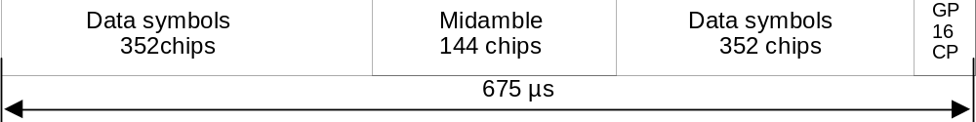
Figure 6. Burst structure.
(GP denotes the guard period and CP the chip period.)

Transmission of L1 Control Signals
The burst for dedicated channels provide the possibility for transmission of L1 control signals in uplink and downlink respectively.
The transmission of L1 control signals is necessary in all communication procedures. As an example, this section show the L1 control symbols in the burst except in FACH and RACH which more symbols are required for L1 control signals. Hence the midamble structure and length is not changed. The L1 control signals are to be transmitted directly adjacent to the midamble, Figure 7 shows an example of the position of the L1 control signals in traffic burst.

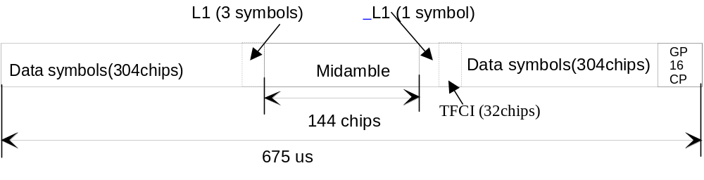
Figure 7. Example of L1 control signal position in traffic burst
(GP denotes the guard period and CP the chip period)
The L1 control signals are spread with the same spreading factor (SF) as the data parts. The SF of the burst which contains the L1 control signal is applied to both data and signalling and shall be constant, except when a negotiation between transmitter and receiver initiates a change of the SF.
Note: In Figure 7, The L1 control signals content 4 symbols, they are:

Power Control (PC) | 1 symbol
Timing Advance (TA) | 1 symbol
Stealing Flag (SF) | 1 symbol
CRC | 1 symbol

    - Training sequences for spread bursts
The training sequences, i.e. midamble, of different users active in the same time slot are time-shifted versions of one single periodic basic code. Different cells use different periodic basic codes, i.e. different midamble sets. In this way joint channel estimation for the channel impulse responses of all active users within one time slot can be done by one single cyclic correlation. The different user specific channel impulse response estimations are obtained sequentially in time at the output of the correlator. Following this principle it is shown hereafter how to derive the midamble from the periodic basic code.
Section 5.2.2 contains a description of the spread speech/data bursts. These bursts contain Lm midamble chips, which are also termed midamble elements. The Lm elements 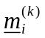; i=1...Lm; k=1,...,K; of the midamble codes 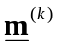; k=1,...,K; of the K users are taken from the complex set
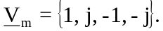 ()
The elements 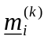 of the complex midamble codes fulfil the relation
()
Hence, the elements of the complex midamble codes of the K users are alternating real and imaginary.
With W being the number of taps of the impulse response of the UE radio channels, the Lm binary elements 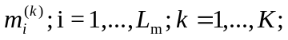 of (2) for the complex midamble ; k=1,...,K; of the K users are generated according to Steiner’s method [1] from a single periodic basic code
()
The elements 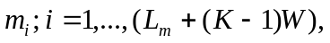 of (3) fulfil the relation
()
The P elements 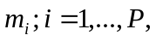of one period of m according to (3) are contained in the vector
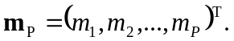 ()
With according to (3) the Lm binary elements 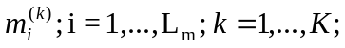 of (2) for the midamble of the K users are generated based on Steiner’s formula
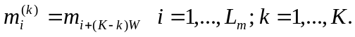 ()
In the following the term ’a midamble code set’ or ’a midamble code family’ denotes K specific midamble codes ; k=1,...,K. Different midamble code sets ; k=1,...,K; are in the following specified based on different periods 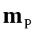 according (5).
In adjacent cells of the cellular UE radio system, different midamble codes sets ; k=1,...,K; should be used to guarantee a proper channel estimation.
As mentioned above a single midamble code set ; k=1,...,K; consisting of K midamble codes is based on a single period according to (5).
In the following several exemplary periods according (5) which can be used to generate different midamble code sets ; k=1,...,K; will be listed in tables in a hexadecimal representation. As shown in Table 5 always 4 binary elements 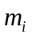 are mapped on a single hexadecimal digit.
Table 5. Mapping of 4 binary elements 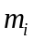on a single hexadecimal digit
4 binary elements 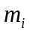 | mapped on hexadecimal digit
-1 -1 -1 -1 | 0
-1 -1 -1 1 | 1
-1 -1 1 –1 | 2
-1 -1 1 1 | 3
-1 1 -1 –1 | 4
-1 1 -1 1 | 5
-1 1 1 –1 | 6
-1 1 1 1 | 7
1 -1 -1 –1 | 8
1 -1 -1 1 | 9
1 -1 1 –1 | A
1 -1 1 1 | B
1 1 -1 –1 | C
1 1 -1 1 | D
1 1 1 –1 | E
1 1 1 1 | F

The mean degradation’s [2, equation (38)] which serve as a quality information of the periods 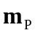 according to (5) and hence of the specified midamble code sets ; k=1,...,K; will be also given.

Midamble Transmit Power

In principle, the midamble transmit power would be the same as the data symbols in the same burst.

  - Common control physical channels (CCPCH)

    - Downlink common control physical channel
The BCH, the PCH or the FACH as described in section 4.1.2 are mapped onto one or more downlink common control physical channels (CCPCH). In such a way the capacity of BCH, PCH and FACH can be adopted depending on the operator’s requirement.

Spreading codes
The downlink CCPCH uses fixed spreading with a spreading factor SF = 16 as described in section 5.2.1.1.

Burst Types
The bursts type described in section 5.2.2 are used for the downlink CCPCH.

Training sequences for spread bursts
The training sequences, i.e. midamble, as described in section 5.2.3 are used for the downlink CCPCH.
    - The physical random access channel (PRACH)
The RACH as described in section 4.1.2 are mapped onto one or more uplink physical random access channels (PRACH). In such a way the capacity of RACH can be adopted depending on the operator’s requirement.

Spreading codes
The uplink PRACH uses fixed spreading with a spreading factor SF = 16 as described in section 5.2.1.1.

Burst Types
The burst type described in section 5.2.2 are used for uplink PRACH

Training sequences for access bursts
The training sequences, i.e. midamble, as described in section 5.2.3 are used for the uplink PRACH.
  - The physical synchronization channel (PSCH)

As described in section 5.1.2, the PSCH is located that:
The downlink PSCH is located in DwPTS as shown in Figure 4,
The uplink PSCH is located in UpPTS as shown in Figure5,
- Mapping of transport channels to physical channels

This section describes the way, in which transport channels are mapped onto physical resources. Figure 8 shows the mapping.

Transport Channels | Physical Channels
DCH | Dedicated Physical Channel (DPCH)
ODCH*

USCH**
DSCH**
BCH | Common Control Physical Channel (CCPCH)
FACH
PCH
RACH | Physical Random Access Channel (PRACH)
ORACH*
SCH | Physical Synchronization Channel (PSCH)
*: in case of ODMA networks
**: FFS
Figure 8 Transport channel to physical channel mapping

In the sequel, we use the term’s physical channel and resource unit (RU), a physical channel is defined as the association of one code, one time slot and one frequency. A resource unit (RU) is that part of a physical channel allocated for one subframe.

  - Dedicated Transport Channels

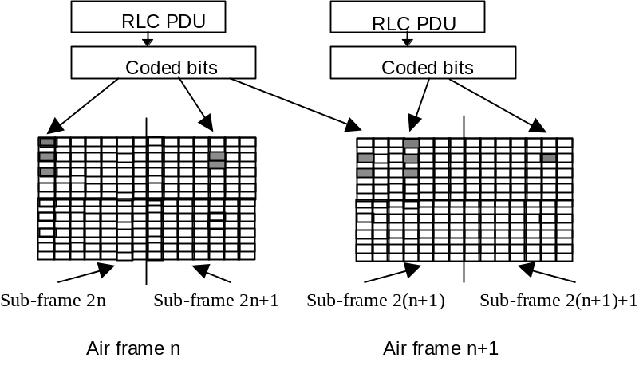A dedicated transport channel is mapped onto one or more sets of time slots and codes within a subframe. An interleaving period is associated with each allocation. The subframe is subdivided into time slots/codes that are available for uplink and downlink information transfer. Each set of time slots and codes over an interleaving period maps to a data unit and a data unit can correspond to one or more FEC code blocks and one or more RLC protocol data units dependent from the service being supported. The mapping is illustrated by the following diagram (Figure 9):

Figure 9. Mapping of PDU onto the physical bearer
For NRT packet data services an allocation is made only for a relatively short period of time. In general, for RT services an allocation is made for a certain time period and a release procedure is necessary to release the resource. For the efficient use of resources the time slot/ code set allocated to a radio bearer may be changed from time to time and the resources allocated to a VBR service may increase or decrease along with the changes in the data rate. Traffic channels are power controlled.
  - Common Transport Channels

The following figure (Figure 10) shows the transport channel mapping:
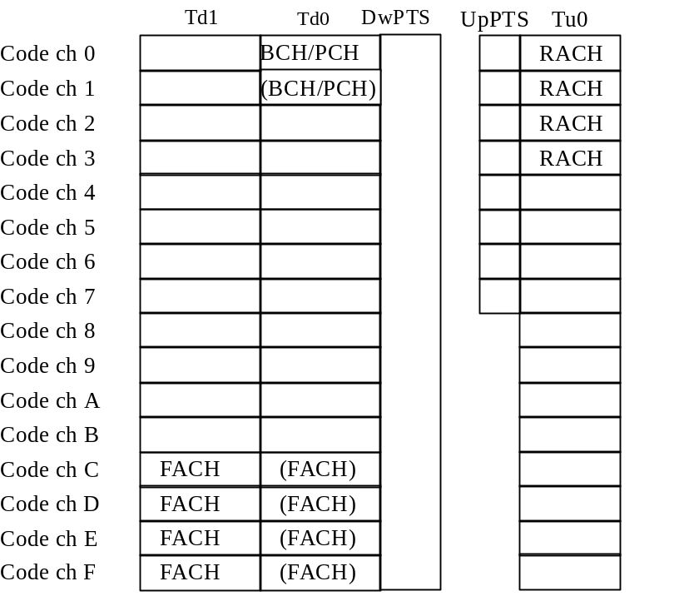
Figure 10 Transport channel mapping

    - The Broadcast Channel (BCH)

The BCH is mapped on at least one RU in the first downlink time slot (Td0) per subframe. The BCH has higher transmission power level (9-11dB higher than average power level in one RU) with omni-directional or sectorial pattern (without beamforming) to cover the whole cell range. The RU allocated for BCH would be shared with other common control channels: PCH, according to a superframe structure.

    - The Paging Channel (PCH)

PCH is a special broadcast channel used to paging UEs from base station side,as mentioned above, it is also mapped onto the same downlink time slot0 as BCH followed by DwPTS( see reference[1]) ,which is always transmitted with the same power level and antenna pattern as those of the BCH. PCH and BCH will occupy their own blocks in the multi-frame structure.

    - The Forward Access Channel (FACH)

FACH can be used for making response to UE’s random access request and in pairs with the Radio Access Channel (RACH).The FACH can be mapped onto more than one (up to 8) RU in the first (Td0) or second (Td1) downlink time slot per subframe. The location and number of the FACH is indicated on the BCH. FACH may or may not be power controlled. FACH has average transmission power lever and its radiation pattern is beam formed.
    - The Random Access Channel (RACH)
RACH channel is designed for uplink random access by UE ,it is mapped onto more than one (up to 8) RU in the first uplink time slot (Tu0) per subframe. The same time slot may be used for RACH by more than one cell. Multiple transmissions using different codes could be received in parallel. The location allocated to RACH in the time slots is indicated on the BCH. The RACH uses both power control and uplink synchronisation control.
    - The Synchronization Channel (SCH)
The SCH is mapped onto the PSCH as described in section 5.4.
  - Multiframe structure

A strong requirement for the multiframe structure comes from the realization of handover to UTRA FDD - TDD and the GSM compatibility. In this respect the superframe and multiframe structure have to be compatible with UTRA FDD – TDD and harmonised with GSM.
Thus in the proposed structure a superframe is composed of 72 radio frames (144 sub-frames) each of length 10 ms. So the superframe period is 720 ms.
All frames in the traffic channel multiframes are used to carry both user data and dedicated signalling. The superframe matches exactly a UTRA FDD-TDD multiframe ensuring the compatibility.

History
Document history
V0.1.0 | 1999-04 | Document created based on the documents CATT TD-SCDMA RTT V 0.5
V1.0.0 | 1999-05-12 | Document updated based on the 3GPP S1.21 V2.0.0 and the discussion between Siemens and CATT.  This draft has been discussed in the CWTS WG1 Ad Hoc1#1 meeting, Beijing, May 12th, 1999.
V1.1.0 | 1999-05-21 | Document updated based on the CWTS WG1#3 meeting, Beijing, May 21st, 1999.
V1.2.0 | 1999-07-21 | Revised after discussion
V1.3.0 | 1999-08-05 | Revised after discussion in CWTS WG1 Ad Hoc1 #2 meeting in Aug5-7,1999
V2.0.0 | 1999-08-30 | Revised in CWTS WG1 Ad Hoc1 #3 meeting in Aug 29-30, 1999
V2.0.1 | 1999-09-16 | Text modification only
V2.1.0 | 1999-10-2 | Chip rate changed to 1.28Mcps
V3.0.0 | 1999-10-14 | Document accepted in CWTS WG1 Ad Hoc1 #4 and CWTS WG1 #5meeting in Beijing, Oct.14, 1999
Editor for C102, Physical channels and mapping of transport channels onto physical channels (TD-SCDMA), is:

Mr. Guiliang Yang
CATT

Email: yanggl@pub.tdscdma.com

This document is written in Microsoft Word 97.

